Words by Anne Coote RALF (2020)
Dr Wendy Taheri, Research Microbiologist USDA-ARS reports that 90% plus of all forage plants cannot survive without Arbuscular Mycorrhizal Fungi (AMF). Plants need this symbiotic relationship with AMF to thrive, understanding this concept allow us to managed and improve soil health & overall pasture productivity. This process of symbiosis is referred to by scientists as symbionts.
The plant and AMF relationship is a very active and effective one in fact portion of the plants genome is the control centre for monitoring the symbiosis of AMF. AMF actually live inside the plant roots and play a significant role for the plant but also for overall soil health supplying around 50% of a plants nutrients and much more in native grasslands s needs, . They collect up micronutrients and convert them for the plants use, help transfer water by doubling the water availability and produce protective compounds to protect the plants against pests. In return the plant produces sugar and regulates the carbon transfer to ensure a balanced trade of requirements. As a result of this relationship the AMF can also share nutrients with other plants and across species, they also produce glomalin which take care of soil structure along the way.
AMF as an organism produces extensive underground trails of hyphae, they reproduce by releasing spores into the soil. It is the spores which scientists identify and count through the lens of a microscope.
Richard Teague Texas A&M also reports that were landholders are using multi-paddock (TCG) management with a focus on the plants there are considerably higher fungal populations than when compared to set stocking of low or high livestock numbers continuously.
AMF contributes to
- Increased yield – from 23 – over 200% increase
- Free phosphorus – plants exchange carbohydrate in exchange for P on tap.
- Increased water uptake and effectiveness via the hyphae in addition to the plant roots
- Inbuilt bio protectant, protecting the plant from soil disease, warning other plants of potential invasions.
By understanding AMF and managing to improve these relationships everything else will follow along.
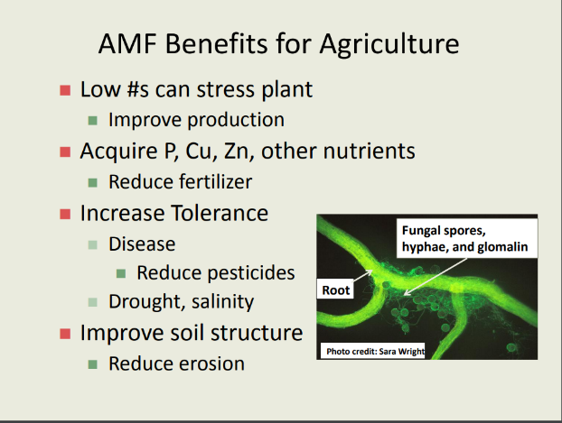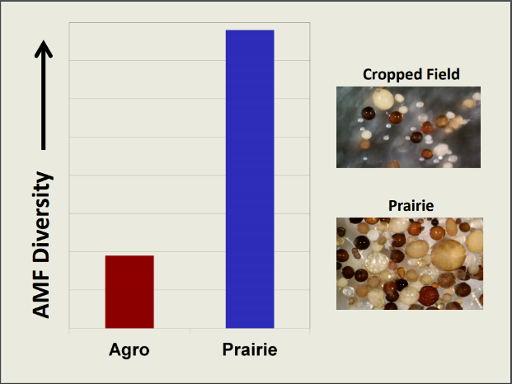
Reference
Taheri, Wendy Dr (2017) USDA-ARS The Benefits of Biologically Healthy Soils
Teague, Richard Texas A&M

