Cover Story on Cover Crops
A cover crop is a specific crop, or a multi-species planted crop primarily grown for soil benefits. Commonly used to create ground cover to help build and improve soil structure & fertility, suppression of weeds and pests and promote biodiversity of plant species and pollinators.
John Hickson ‘Eural’ Boomi (committee member of the Northern Slopes Landcare Group) is an advocate for regenerating his properties soil health and in addition to using time control grazing & pasture cropping this season has planted a multi-species cover crop.
The cover crop was planted into fallow country in late March 2020 with a multi-species of mix of Oats, Triticale, Barley, vetch, field peas, medics, forage and tillage rape, with worm extract applied to bare seed at 5 lts/ha (left). Another area was planted as a pasture crop into existing native perennial grasses after grazing (right)
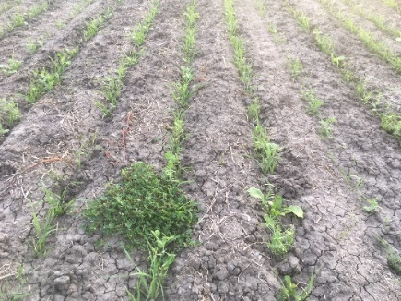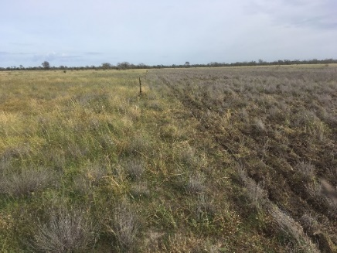
Cover crop Pasture Crop
The cover crop is being grazed with cattle using temporary electric fencing. Cattle were moved every day to begin with and then every few days as they get used to the system. It is critical to manage the livestock in this manner to ensure that the various plant species are grazed evenly and that large amounts of leaf litter are trodden in to the ground to be able to obtain soil health benefits. Crop established well and seen here in July.
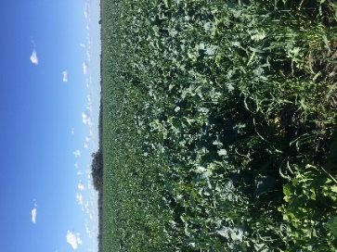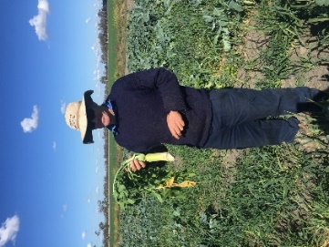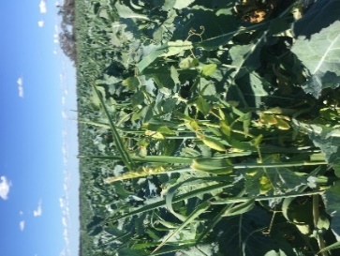
John’s Tips for Cover cropping
- Have a clear objective of what you are trying to achieve with the crop. Is it ground cover, increasing soil carbon, increasing soil fertility, increasing moisture for an ensuing crop or pasture establishment, or is it forage for livestock?
- Observations from a plant’s perspective is important, cow will eat everything it is able to so it is how you manage the grazing that’s important “its not the cow, it’s the how”!
- Diversity is important for soil health, but do we need more than 1 cereal in the mix?
- Grow areas that you can manage.
For North West NSW John views pasture cropping as another great option to increase diversity in native grass country to support the soil biology & improving soil conditions for more natives to germinate & establish. Coote, A. July 2020.

