**Tamworth Regional Landcare Association Small Grants Program 2024**

Project Report for Tamworth Open Garden Trail

Project Commencement: May 2024 Project Completion: October 2024

Total Project Expenditure: $1539

Project Volunteers: 9, plus garden owners and staff of Tamworth Regional Landcare

Garden owners: volunteers of Tamworth Community Garden, volunteers of Nemingha Community Garden, Eliza Weeks, Ryan Brooke and Cat Fogarty, Ali Hunter, Carine and Wayne Collison, volunteers of Currawong Park, Denise Fitzgerald, Pauleen and Anthony Parker, Nicola Stockwell, and Patrick and Gina Mahony.

Locations: Tamworth Community Garden, Nemingha Community Garden, 6a Rosehill Place, 1 Ruthning Avenue, 2524 Duri-Dungowan Road, 6 Mulga Place, Currawong Park, 28 White Street, Landcare Nursery, 85 Yarmouth Parade, 9 Patrick Street, 160 Brisbane Street.

Partners: TRLA, TRC, National Water Week, Tamworth Water Security Alliance, Parents for Climate, Tamworth Bird Watchers, Tamworth Community Garden, Nemingha Community Garden, Manilla Solar.

**Key Project Activities:**

To host an open garden trail in Tamworth on the October long weekend in 2024. We chose gardens that suited our criteria of water wise, verge planting, food producing, and/or habitat producing (planted with natives). We envisioned an event that would provide practical inspiration to visitors on how to alter their gardens to be more water wise, productive, and beneficial to native species. One secondary aim was to increase the public awareness of our two community gardens, and to drive sales for the TRLA nursery. We chose to start both days at Currawong Park to increase awareness of this regeneration project as another secondary aim. We ended up with 12 locations in Tamworth and the surrounds that opened to the public on October 26th and 27th.

**Achievements**

1. We allocated 479 free tickets
2. We had around 90 people take us up on our offer of free hot drinks
3. Each garden had around 100 visitors, except for the verge gardens which averaged around 50 visitors each
4. Many visitors took us up on the offer of information on TRC water rebates and Manilla Solar information
5. Some visitors signed up to join to the community gardens
6. We created a website that we can continue to use for future events
7. We believe that this event created strong interest in water wise gardens, verge plantings, home food production, and native plantings.

This event was designed to closely fit with TRLA’s objectives of:

**1. Deliver the mission of TRLA in a changing social and environmental landscape**

1. We promoted gardens that restored and conserved biodiversity through native plantings and water wise design features such as less lawn, heavy mulch, and drought tolerant species.
2. We engaged with community members by encouraging our garden owners to answer any questions that visitors had, and educating them on the best ways to have a successful garden in our local area. This local expertise was highly valued by our visitors, with many commenting of the diverse native fauna that was present in the gardens. We also directed visitors to the TRLA nursery, where they were able to engage with TRLA members.
3. The participating community gardens encouraged visitors to return and use their space to grow and harvest food. This promoted sustainability by reducing carbon miles for produce, and also highlighted to locals that food producing gardens are possible even in our dryer climate.

**4. Human Health through Healthy Soils**

* 1. This project supported the development of urban food production by featuring gardens that contained fruit trees, vegetable patches, orchards, and native food species. We also promoted out local community gardens which are open to the public and grow a wide variety of foods.
  2. We believe that this project will help build healthy communities as many visitors remarked that after visiting the gardens on display, that they were inspired to start their own vegetable plots or plant fruit trees. The community gardens also reported that they gained new users from this event.

**Future Plans**

We are in discussion with volunteers around holding this event either every year or every second year. We would plan to highlight different gardens next time, but invite some of the same participants back, such as the Community Gardens, Landcare Nursery, and Currawong Park.

**Report Prepared by**:  
Alice Milson, Lead coordinator, TRLA member and Tamworth Open Garden Trail

Mob: 0418 988 683  
Email: alicejmilson@gmail.com

**Gallery**

Currawong Park information stall with Manilla Solar info, TRC water rebate info, and volunteers on Open Garden Trail Saturday

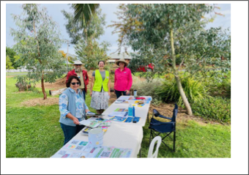

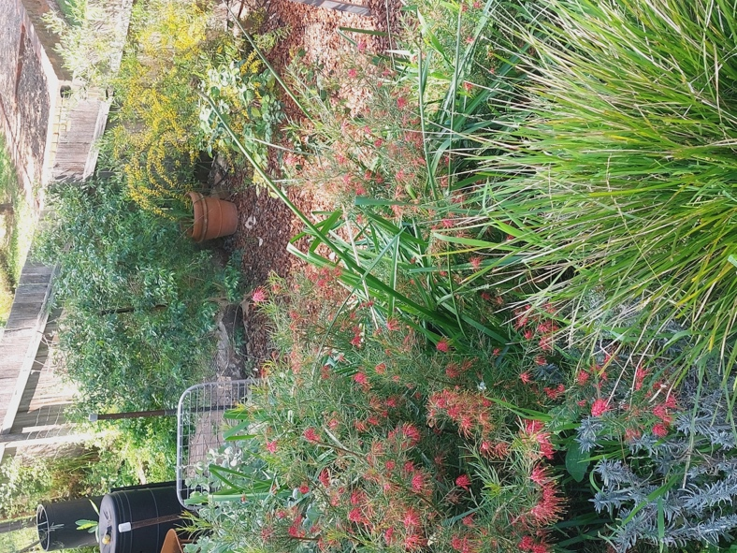

One of the gardens with drought tolerant species and mulch on display

Visitors to Nemingha Community Garden

Our coffee van providing free hot drinks to garden visitors

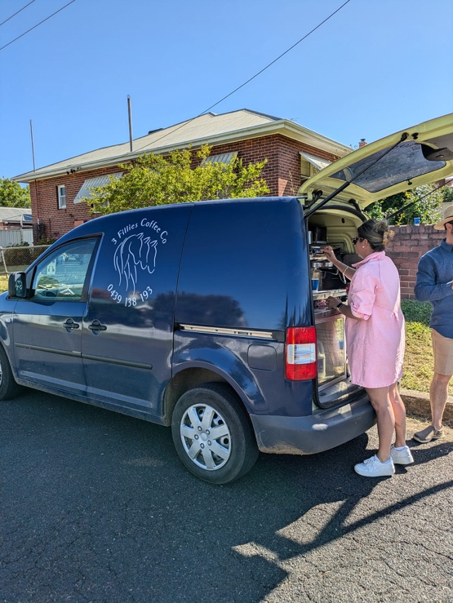

Lead coordinator receiving an award from TRC for the event

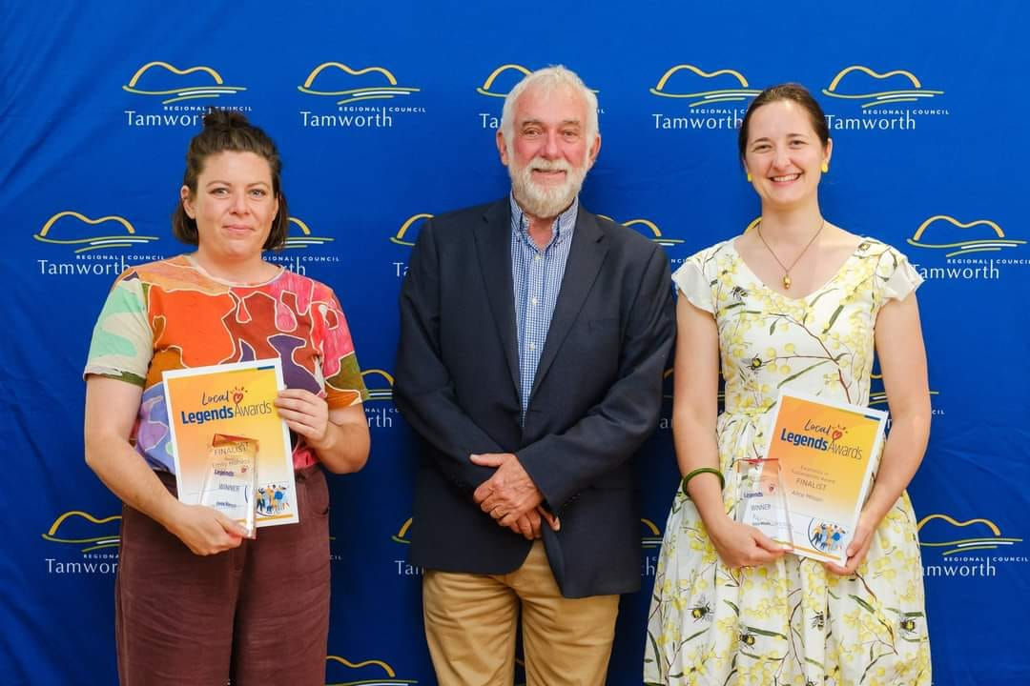

A new, drought tolerant garden made after receiving advice from Open Garden participants

