

**PRELIMINARY OVERVIEW OF THE WALLABADAH CREEK SUB-CATCHMENT FROM A GEOMORPHOLOGICAL AND HYDROLOGICAL PERSPECTIVE (Report)**

|  |
| --- |
|  |

Prepared for the Wallabadah Creek Catchment Community

**28 February 2021**

**Cover Photo**

This is a remnant waterhole on the former valley fill surface, photographed in November 2020, of Water Gully on the Wallabadah Racecourse. The creek flows from the left to the right of the photo. Site observations suggest the combined sequence of processes by which the pond formed included the localised loss of ground cover under the river redgum and subsequent flows concentrating around the tree’s trunk, scouring the area adjacent and downstream of the tree.

This pond has been dug out/deepened (possibly more than once) to better provide stock and horse water. However, if it is not dug out, in the future, it likely it will fill in with sediment as the pond is completely or substantially disconnected from the creek and this scouring process is no longer occurring.

These ponds and the floodplains in which they were found were once common within Water Gully drainage system and its larger sub-catchment, the Wallabadah Creek Catchment. These ponds provided multiple water storage areas where water had the opportunity to infiltrate into the underlying alluvial aquifer.

This is another water storage and ground infiltration process which has been lost due to the wholesale erosion and expansion of the channel drainage network.

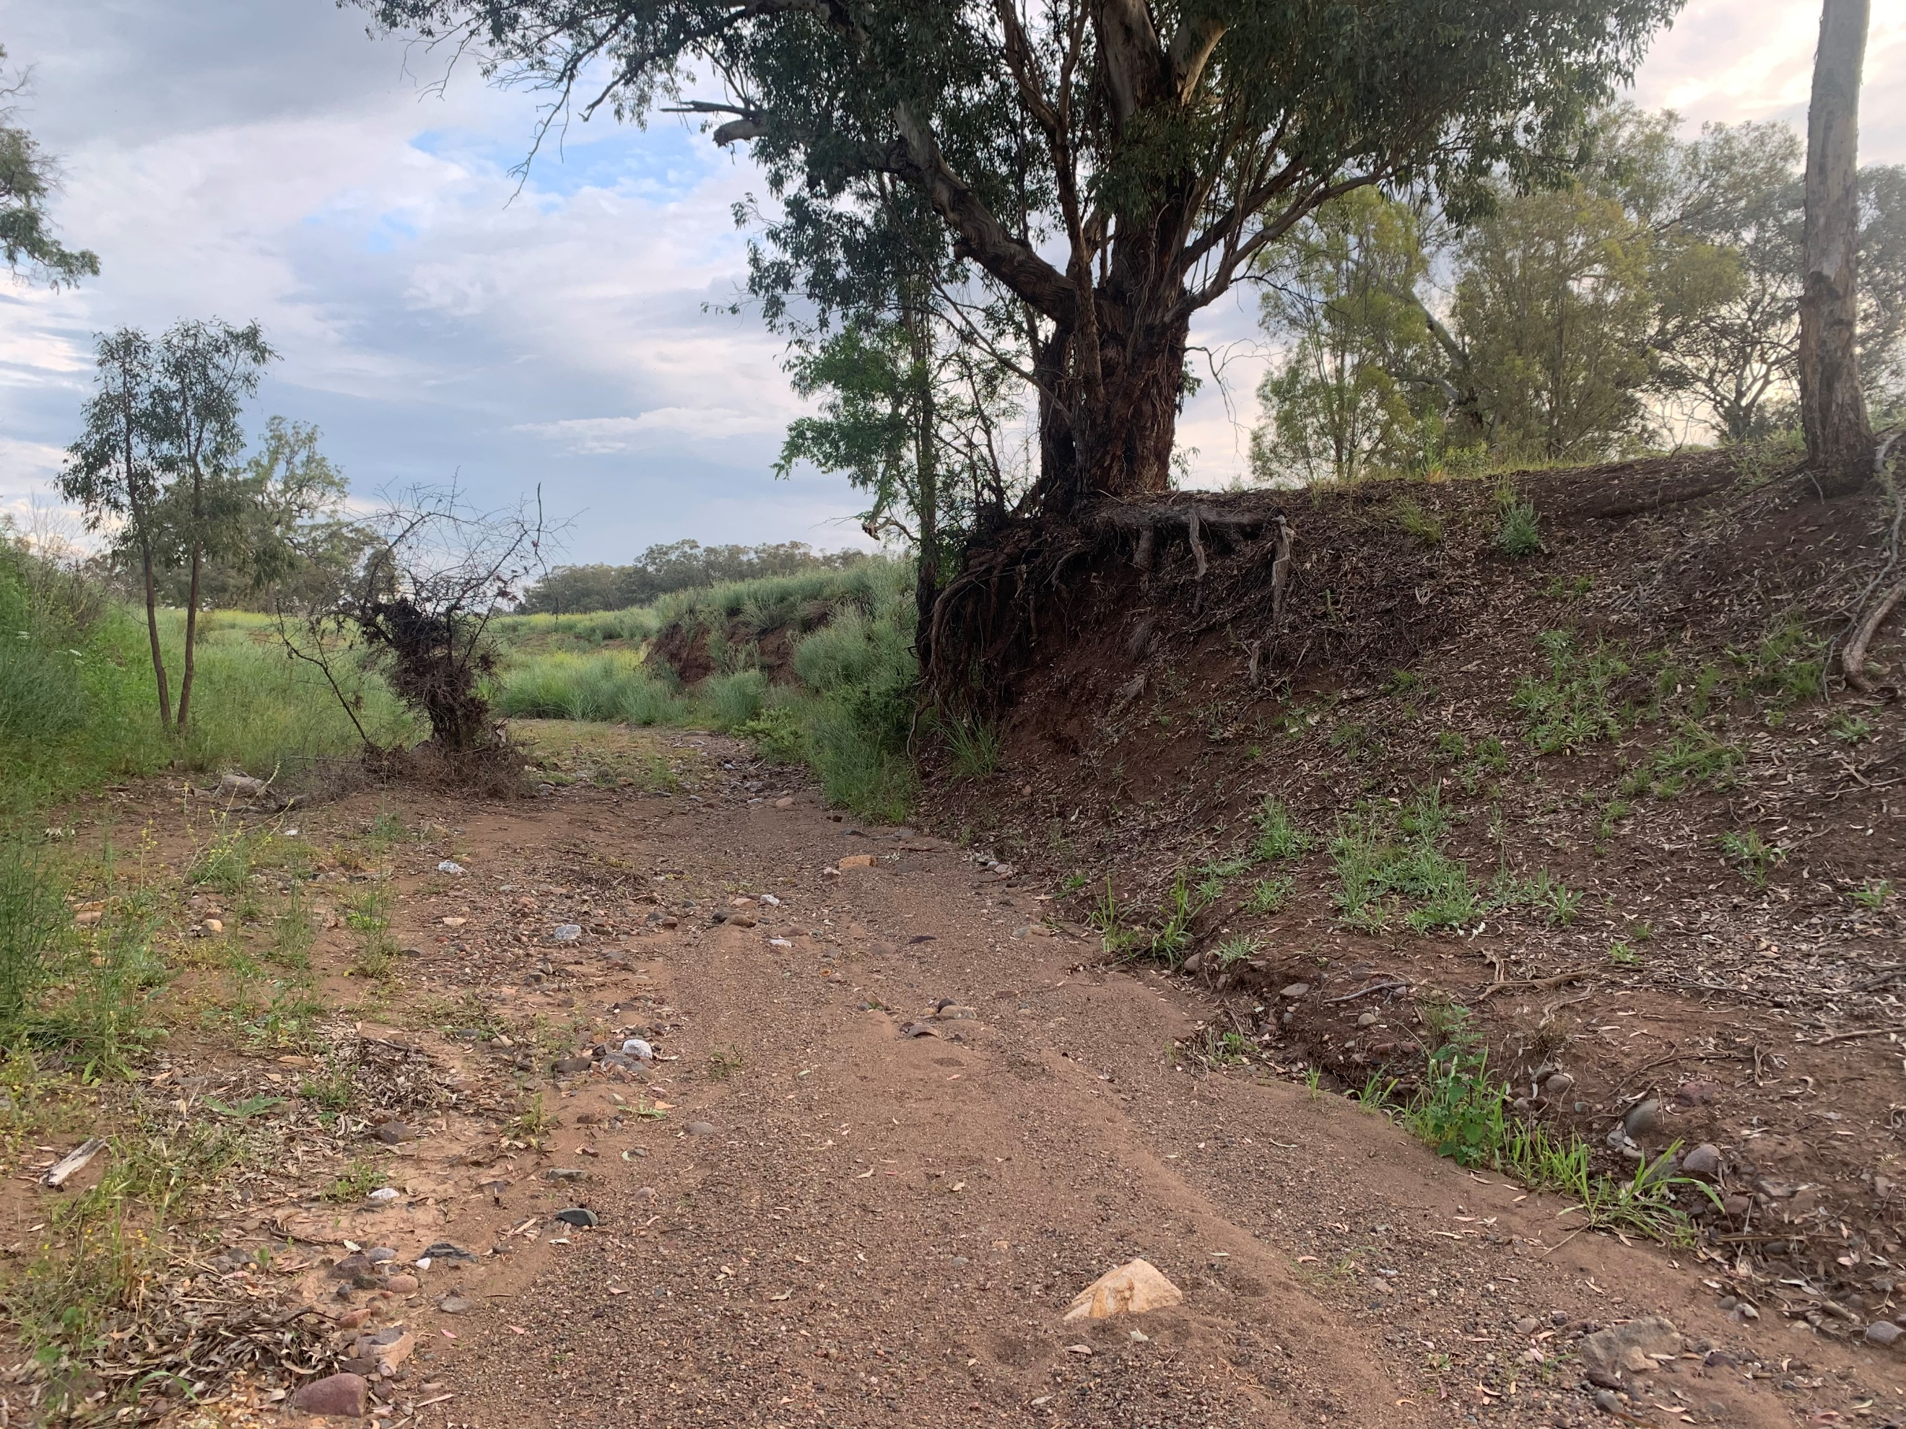

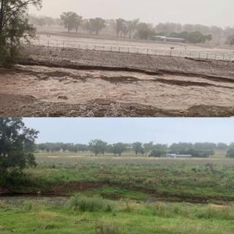

**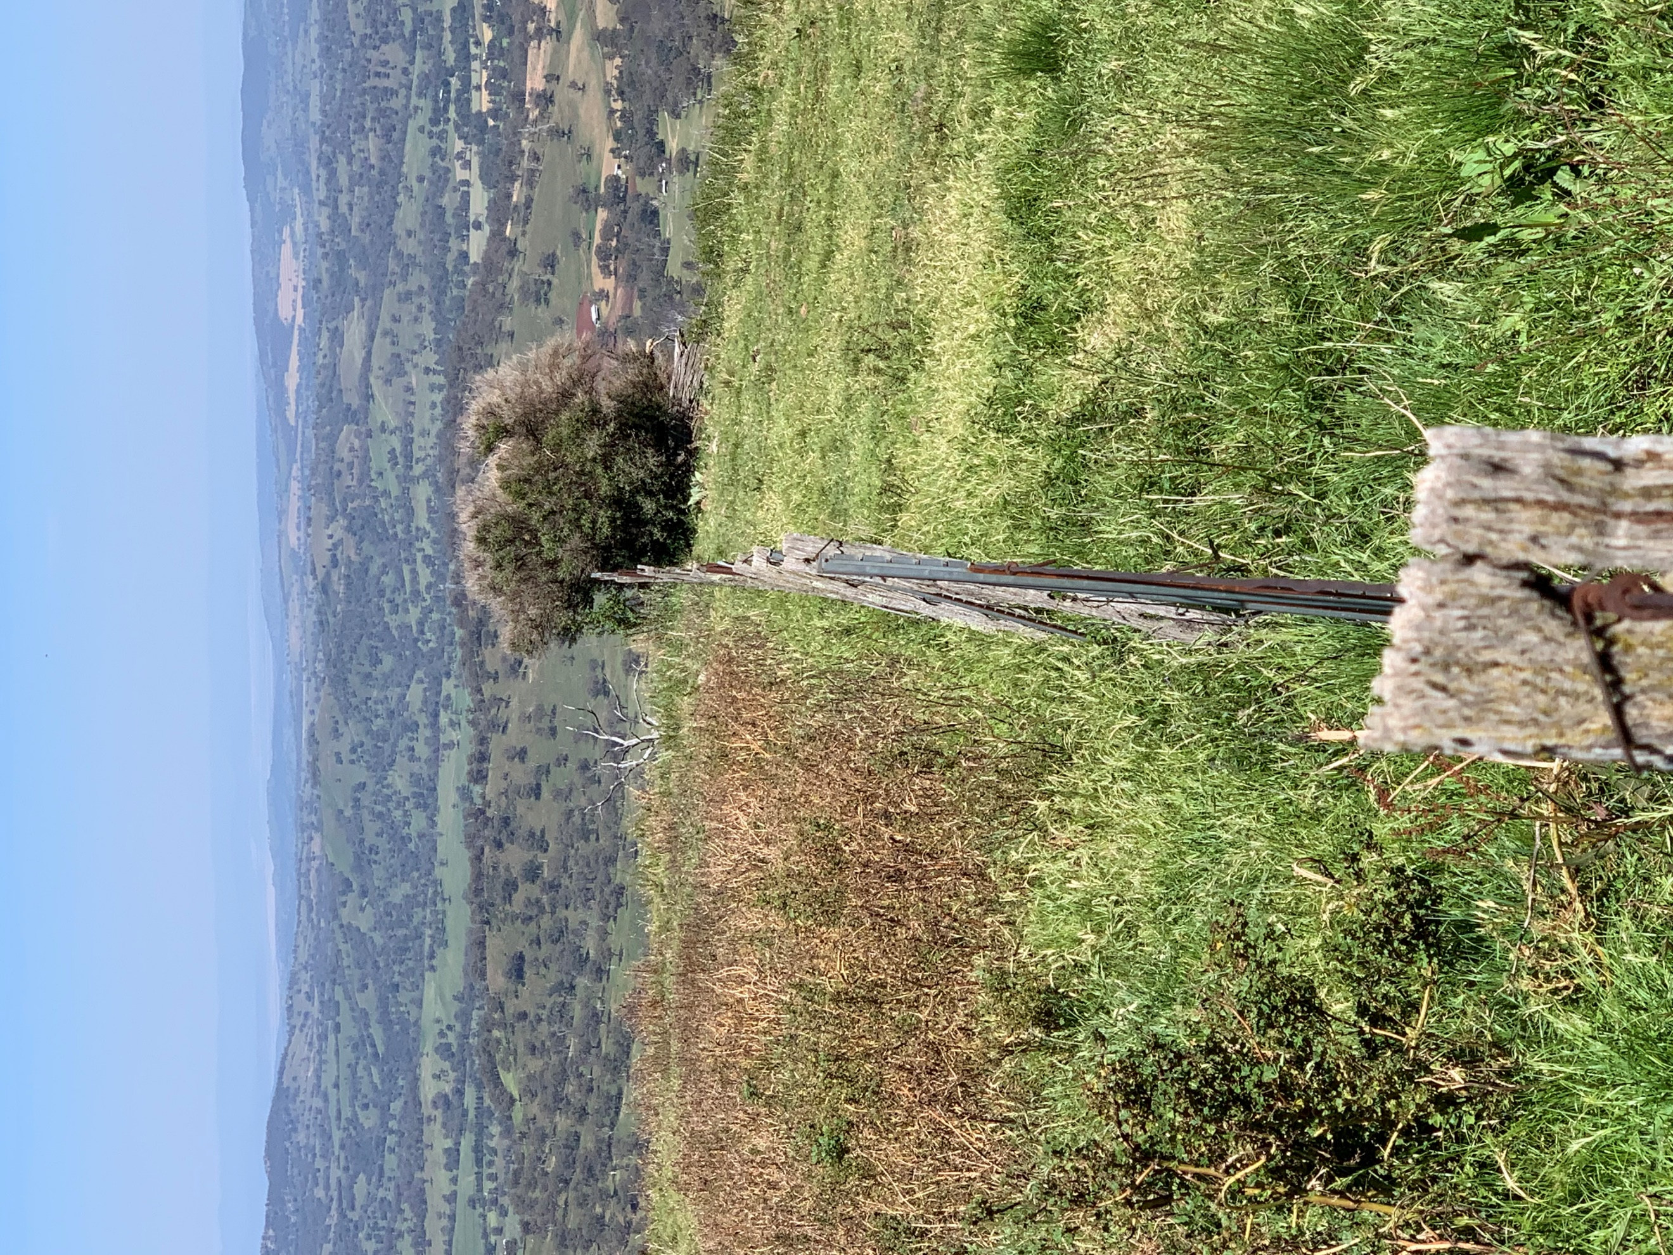**

|  |
| --- |
|  |
| **Map 1** - Drainage Map of the Wallabadah Creek Sub-Catchment.  The Wallabadah Village is highlighted by the green area and the Wallabadah Nature Reserve (WNR) is the highlighted by the mauve area. The Nature Reserve’s eastern boundary marks the top of the catchment. The balance of the catchment is private agricultural landholdings in 15 lots.  The Wallabadah Creek flows in a westerly direction from its discrete watershed on the Great Dividing Range through the Village (where it becomes known as the Quirindi Creek) and exiting into the Mooki-Namoi system/Liverpool Plains at Flora’s Ponds.  Photo inserts (clockwise from top left) 1. Water Gully late 2019 2. Wallabadah Creek toward the Wallabadah Station Woolshed in January 2020 and in January 2021. 3. A westerly view over the sub-catchment toward the Liverpool Plains from the main range above the source of Back Creek 4. Healthy stream bed running out of the WNR. 5. A remnant billabong in the Wallabadah Racecourse. |

**Wallabadah Creek Catchment Water Statistics**

1. Size – circa 17000 ha
2. Perimeter of the catchment – 86 kms
3. Distance top to bottom – 22 kms
4. Average Rainfall – 750 - 900 mm
5. Total annual water into catchment based on Average Rainfall at Wallabadah village (750 mm) – 127,500,000 m3 or 127,500 megalitres or 127.5 gigalitres
6. 2020 rainfall – 950 to 1200 mm
7. Total 2020 based on 1000 mm – 170,000,000 m3 or 170,000 megalitres or 170 gigalitres
8. The predominant geology in the upper catchment is Tertiary basalt with a fractured rock basement overlain by basalt clays soils on the ridges and alluvial soils in the valley floor and the associated drainage lines. A key feature of these soils and underlying geology is above average infiltration rates.
9. Number of discrete rural landholdings – circa 16
10. Number of households – circa 35 excluding Wallabadah village
11. Number of households (including Wallabadah village) – circa 85
12. Wallabadah water supply license (LPSC per annum entitlement) – 60,000 m3 or 60 megalitres or 0.06 gigalitres
13. Annual domestic requirement at average 200 litres/household – 6205 m3 or 6.2 megalitres or 0.62 gigalitres
14. Stock – 100000-130000 DSE
15. Annual stock water requirement at average of 5 litres/day – 625500 m3 or 6255 megalitres or 6.2 gigalitres
16. Total Annual Water Requirement for catchment – 631,705 m3 or 6216 megalitres or 6.82 gigalitres
17. Catchment water surplus – average rainfall less human stock usage – circa 120 gigalitres

**Comparative Statistics**

1. Quipolly Dam – 8,000,000 m3 or 8000 megalitres or 8 gigalitres
2. Chaffey Dam – 102,868,000 m3 or 102,868 megalitres or 102 gigalitres
3. Sydney Harbour - 450,000,000 m3 or 450,000 megalitres or 450 gigalitres
4. Number of Olympic size swimming pools which would be filled from annual catchment rainfall – 50800

|  |  |  |  |
| --- | --- | --- | --- |
| **Table 1: Comparative Statistics on Water** | | | |
| **Location** | **Megalitres (ML)** | **% of Sydney Harbour** | **% of Chaffey Dam%** |
| **WCC (av rainfall)** | **127500** | **28%** | **124%** |
| **Quipolly Dam** | 8000 | 1.8% | 8% |
| **Chaffey Dam** | 102000 | 23% | **1** |
| **Sydney Harbour** | 450000 | **1** | 441% |
| **WCC Surplus to Usage** | **120000** | **27%** | **117%** |

**Some Comments by WCCC Landholders and Community Members**

The following are a selection of comments made by member landholders, managers, employees, long time residents of Wallabadah and advisors during consultations and farm visits in 2020 and early 2021 that provide background, insight and local expertise, and bear consideration:

* ***In a fresh, our Creek used to take 9 to 10 hours to reach Quirindi… old fellas used to say it took a week at the turn of last century. Before 1955, no one remembers the catchment ever flooding….55 in the main creek was the first time. Now it reaches Quirindi in 4 or 5 hours every time it rains, and people see it still going out on the Plain***
* ***Those big blokes care about maximising profit…they don’t care about the rest of us***
* ***Our groundwater has never run out in recorded history…and we were carting water in late 2019, just to keep our stock alive***
* ***It was really dry in 2019 but we still had over 300 mm across the catchment… enough to fill Quipolly Dam 4 times over…clearly this is not about lack of water in the postcode***
* ***Where I had any grass left after this last drought the dams have had trouble filling …some haven’t even filled yet but they’re clean as a whistle. I thought I had a problem until I realised the other dams were mostly full of mud.***
* ***The biggest landowner in the catchment doesn’t live here and its run by blokes who do what they want…there’s a disconnect***
* ***Dad used to say there were [13] springs feeding the Wallabadah Creek, which makes sense when I now know we sit over folded rock…at every fold the underground water was pushed to the surface…but its not like that now***
* ***We missed an ecological disaster this past 12 months didn’t we…all that rain and most of it slow and steady***
* ***That creek used to run 9 months of every year…even in drought it had water holes, but it doesn’t run at all these days***
* ***I feed, and my stock still die or fail to reproduce, and decimate my soils in the process…the only certainty for me is that I get to understand my bank manager better…I’m not doing that again***
* ***We used to have our swimming lessons under the bridge [in the 1960s]…the pool was deep and seemed to go forever. Now you’d be hard pressed to get your shoes wet***
* ***A lot of the older Casuarinas on the high banks died in this last drought…and a lot of the stringybarks as well…in the areas where they have died there’s active erosion of the beds and banks***
* ***This catchment used to be progressive thinkers…early adopters of superphosphate and Soilcon erosion control techniques…even cell grazing…now it seems like it’s one foot in front of the other going nowhere for most of us***
* ***Those blokes that run too hard…or even worse not smart…do us all a disservice…they think we don’t notice***

**Liverpool Plains Shire Council (LPSC) Records Showing Level of New Bore Field Groundwater since 1998 – Figure 1**

Whilst this data is incomplete, it is indicative and in line with what those landholders and Wallabadah residents of long standing have said in the on-ground research for this Report. These observations were expressed to adaptiv during the consultation and the on-ground research for this Report.

It is also consistent with the deepening and expansion of the channels observed across the catchment. One of the most significant aspects of these changes is the reduction of the landscapes capacity to capture and store rain which has resulted in the death of the relatively shallow rooted trees, such as Casuarinas.

The evidence from the field points to the ongoing unmitigated bed erosion, which is progressing through the entire drainage network, as the primary cause of floodplain disconnection and alluvial aquifer lowering. These degrading processes will be discussed in more detail later in the Report.

This evidence also highlights an acceleration in this channel erosion and bed lowering throughout the catchment. Once several thresholds are crossed the system rapidly spirals downward.

|  |
| --- |
|  |
| **Figure 1**: LPSC Records Showing Level of New Bore Field Groundwater since 1998 |

**Another Outcome of the Drought Is Worth Considering – How Much Soil Did the Catchment Lose?**

2020 was a year for rejoicing with over 950 mm – 1200 mm falling in the catchment during the calendar year, with the rehydration of catchment soils which saw catchment wide refilling of the deep, as well as the shallow, alluvial aquifers.

In steep ridged landscapes, such as those in the Wallabadah Creek Catchment, where the average slope gradient is in the order +/- 15 %, Soilcon runoff models developed in the 60s and 70s, identify the runoff potential and the related runoff coefficients as particularly high. Wallabadah Creek Catchment is high risk runoff country.

As such, to avoid significant surface erosion and soil loss Soilcon advise maintaining a minimum critical threshold of 75% ground cover, the threshold below which water runoff is dramatically minimised and infiltration rates proportionally increased. It is to be noted that 75% ground cover is considered the absolute minimum amount required, and that current best practice for grazing systems advocates for a much higher percentage of 100% cover at 1500 kg dry matter/ha, 100% of the time.

When groundcover is ≤75%, the coefficient presumes a loss of 1-5 cm of topsoil for every 100 mm of rainfall. At 100% groundcover 0% runoff and 100% water infiltration can be achieved. In this scenario a net soil loss of zero will occur. The diagram below, Figure 2, drawn from Soilcon literature clearly illustrates this point.

|  |
| --- |
| ****  **Figure 2:** |

The runoff coefficient takes into account a number of other variables, such as existing soil moisture and rainfall intensity. For simplicity, and for the purpose of analysis, these variables have been omitted. In any case, much of the catchment topsoil was loose and unprotected with minimal organic matter at the beginning of 2020. Under these conditions the soil is highly vulnerable to runoff and erosion from any rainfall event.

Importantly, this exercise also assumes the highly conservative assumption that only the first 1 cm of catchment topsoil became mobile during the 2020 calendar year, notwithstanding that there were numerous rainfall events where landholders indicated the drainages ran with significant sediment loads.

Further, it assumes (again conservatively) that there was at least 20% of the subcatchment (including the Wallabadah Nature Reserve) that had more than 70% groundcover at the start of 2020. Visual estimates by some landholders estimate this coverage probably applied to less than 5% of the Catchment.

If we apply these assumptions to a simplified runoff coefficient for the Wallabadah Creek Catchment:

* 17000 ha – 20% 17000 ha = 13600 ha
* 13600 ha x 0.01 m = **1,360,000 m3** – being the aggregate amount of the catchment’s most valuable asset which was carried into the drainages and out of the catchment.
* This is without considering the highly mineral and nutrient rich nature of the first few centimetres of topsoil where, for instance, 100% of available phosphorous is located.

Given that this is likely to be a conservative figure and may be 2 or even 3 times as large in many catchment locations, and topsoil is slow and difficult to rebuild under a traditional stocking/farming regime, ***this is an unsustainable/terminal drain on productivity***; and ultimately agricultural land values.

Having looked at the negative impact of runoff in terms of erosion we can look at the benefits of less runoff.

|  |
| --- |
|  |
| Figure 3: |

Infiltration 101 - The logic is beyond argument, the application at a landholding scale is common sense and the outcomes increase in situ productivity/profit and optimise underground aquifer recharge – what’s not to like?

|  |
| --- |
|  |
| Figure 4: |

1. Wallabadah Creek in the Lower Catchment near Wallabadah in early 2020 and early 2021 – the first showing the drainage carrying a significant load of catchment sediment and the latter, the slow process of recovery and return to productivity
2. Lower Wallabadah Creek hillslope under two separate management racemes in early 2020, late 2020 and early 202. The paddock on the left has been rested for a long period and clearly has some stubble at the start of the drought and the righthand paddock has been set stocked for an extended period. Even during the first rain following the drought 0% runoff was achieved where the paddock to the right it is estimated that the runoff was close to 100% by comparison and there was clear evidence of erosion and siltation. The significantly less growth and litter accumulation illustrates that pasture recovery after soil loss is slower and more uncertain.

**What Can We Conclude from These High-Level Statistics and Stakeholder Observations?**

* The overwhelming positive is that, even in the face of variable climatic conditions, Wallabadah Creek subcatchment is still catching more than enough rainfall to support its residents and their agricultural endeavours.
* It remains high value agricultural farmland built on deep rich basalt based soils.
* The threat is that the catchment is no longer retaining as much of its rainfall as it should, and the conditions for slowing, catching and spreading that water are deteriorating, now more visibly than ever.
* We can also say with complete certainty that **catchment water security is not impacted by downstream activities or irrigators**. Quite the opposite is true, as is reflected by the history of the Wallabadah village bore field which is fed from catchment aquifers. Like all water, catchment water obeys the laws of hydrology and gravity.
* The 2015-2019 drought and its breaking, which prompted the catchment landholders to form the Wallabadah Creek Catchment Community, provided a stark illustration of the existential hydrological and morphological breakdown.
* However, droughts themselves have always been in this catchment, and will forever be here. Of themselves, they are not the primary issue.
* The issue, which can be addressed, is the effects of changed agricultural land use over the past 180 odd years, and their continuing impacts.
* As a general truism, once rainwater runs from source and gets into catchment drainages it is lost (dams or no dams) to the catchment inhabitants. It cannot infiltrate and rehydrate soils or groundwater aquifers.
* Not only is water lost to the catchment, but it also carries away high value catchment soils with it and, in a vicious cycle, exacerbates water loss and velocity which lower beds even further. The comment above from a long time resident of the community about the increasing speed of catchment flooding reaching Quirindi rings true!
* If there is to be a reversal of the long term deterioration, and a maintenance of productivity into the future, rainfall needs to be slowed, caught and spread at source from high in the catchment to the bottom. It is truly a whole of community whole of catchment issue.
* The other overwhelming positive, which underwrites this preliminary Report and the comments and recommendations made in it, is that once recognised by land users, the deterioration of catchment water assets can be addressed/reversed by land users over time.
* Many of the measures land users may need to adopt are far beyond the ambit of this Report or the experience or expertise of the author. However the members of the WCCC are commended for recognising an issue and considering ways of addressing it.

# Introduction – Background to Report

The Wallabadah Creek Catchment Community (WCCC) is an autonomous subcommittee of the Tamworth Regional Landcare Association(TRLA) representing 17 landholder members across the Wallabadah Creek and Jacob & Joseph Creek sub-catchments. Membership speaks for over 60,000 acres including the relevant watersheds of the sub-catchments and, in the case of the Wallabadah Creek sub-catchment, well over 85% of the subcatchment area. The majority of the balance is managed by NSW National Parks & Wildlife Service (NPWS), an active and interested stakeholder.

Both sub-catchments are discrete independent hydrological systems, and in each case the surface, shallow and deep groundwater aquifers are inter-linked. Due to the geology of the catchments and their position at the very top of the watershed, they are fed entirely by rainfall falling within the catchment. We can say with certainty that there are no exogenous aquifer inputs to the catchments, as they back into folded basalts which were the product of the formation of this section of the Great Dividing Range. The impact of that folding is seen by landholders in drainages where water expresses downstream of a dry upstream section.

We can also say with assurance that, with the exception of Wallabadah village, there are no calls on the catchment aquifers outside landholder usage. Wallabadah Creek Catchment Water obeys the laws of gravity and hydrology and runs to its lowest point at the a sandstone fault line in the geology at Flora’s Ponds. **To suggest catchment water security is affected by anything below that point in the catchment defies the fundamental laws of gravity and physics.**

For over 180 years the predominant land use has been stock grazing. More recently, as a result of market and exogenous conditions (e.g. wild dogs and other feral pressure) , cattle and fodder cropping have become more common, but sheep grazing remains the predominant land use activity.

Aside from member agricultural and personal usage, the only significant external user of the water resource is the village of Wallabadah, with a license for 60M/annum. The water sourced from aquifers emanating from the Wallabadah Creek subcatchment is the only source of water, apart from household rainwater, for the village. The village bore field is managed by Liverpool Plains Shire Council, (LPSC) another involved stakeholder.

The village bore field, drawing from the alluvial aquifer in the lower Wallabadah Creek Catchment, went dry in early the early 2000s, which precipitated LPSC analysis of the deeper aquifers, and necessitated the newer bores on Old Wallabadah Creek Road.

During the recent 2015-2019 drought a number of historically reliable water sources went dry, and farmers were forced to import water, and the level and water quality of the bore field servicing the village of Wallabadah dropped precipitously – see page 6.

*Among other things, this makes the village community a key stakeholder in the upstream management of the Wallabadah Creek Catchment, and the water security initiative. The links and accountability between* ***all*** *Wallabadah Creek Catchment land and water users is immediate and direct. This points to the desirability and importance of engagement and participation by the entire catchment community.*

The primary aim of WCCC is to work toward regeneration and long term security and health of its water resources and in particular its underground aquifers. It recognises that underground water security is fundamental to the viability and, in fact, continued existence of future agricultural operations in the sub-catchment. It also recognises the need for agricultural operations within the catchment to be and remain profitable.

WCCC has mandated adaptiv to review the catchment drainages, both at a landholder/member and catchment scale, and explore hydrological practices and options for landholders and the WCCC to better manage their available and future water resources.

adaptiv were also involved in the design and implementation of the first 2 stages of the Water Gully Rehabilitation Project (Jobys Hill Project), at the bottom of the Wallabadah Creek Catchment, conducted by a landholder member in partnership with NWLLS. These works provide a demonstration of the principles and implementation of drainage management and rehabilitation.

This Report represents one component of the WCCC information gathering process – hydrology, the other elements being soils, pastures and biodiversity - which can be used to inform their management and project activities, and the development of a catchment management plan to guide the operations of members.

**Project Objectives**

These are summarised as follows:

* To achieve a working understanding of the Wallabadah Creek Catchment hydrology and morphology through ground truthing exploration and landholder feedback
* To record and present the activities, outcomes and learnings since the initial Stage I works on the Jobys Hill Water Gully Project in October 2019 including impacts creek morphology, technology applications and local materials.
* To develop a relationship of trust with landholders, in order to be able to elicit their information and in situ knowledge and to develop their capacity to understand and implement solutions
* To combine the information obtained from the field visits, in situ observation and catchment works with current scientific and technical principles to inform/advise the landowners and the WCCC on future water/property management principles and practices.
* To recognise at all times that the primary objective of the WCCC members is long term water security and sustainability to support viable agricultural operations in the catchment

# Report Aims

The Report aims are as follows:

1. To provide an inventory of the natural water resources of the Wallabadah Creek Catchment.
2. To present a preliminary analysis of catchment wide drainage line health or otherwise.
3. To report on the activities and learnings to date at the Jobys Hill Water Gully Project. The success of this project provides an important demonstration site for works in the broader catchment.

Extra information has been included to explain some of the principles behind these works, and the observed benefits of these rehabilitation efforts on landscape productivity and farm viability.

1. To table the information gained from property visits including key topics discussed with the catchment landowners. Particular focus is placed in this Report on the information gained from those discussions which have relevance for the broader WCCC.
2. Where appropriate, additional research has been undertaken to validate and formulate recommendations.
3. Landholder inspection reports were prepared and submitted to the WCCC and specific landholders. Where complete, these are available on the WCCC Google drive for public viewing with the consent of the WCCC and the relevant landholder.
4. Where specific management actions were discussed, site-specific advice has been provided to WCCC and the relevant landowner to assist their interest in progressing remediation works, including supporting relevant grant applications.
5. adaptiv understand a number of these applications were successful and projects are either underway or complete.
6. The Report has identified a number of potential knowledge gaps and makes some key recommendations regarding further study.
7. The Report also makes a number of general recommendations directed at landholders and the catchment.

# On Ground Research Activities

An adaptiv representative travelled to the Wallabadah Creek Catchment for a week in March 2020 to gather information for this assessment, as well as assisting the implementation of Stage II/III works at the Jobys Hill Water Gully Creek Rehabilitation Project.

4 days were allocated within the week to meet with landowners across the catchment to discuss matters relating to landscape rehabilitation/rehydration.

The adaptiv representative also visited Wallabadah in late November for 7 days to consolidate and confirm various aspects of the drainages (after some 800 mm of rain during the intervening period). In particular, adaptiv’s work plan was to assess the catchment watershed, the full extent of both Back Creek to its junction with the Wallabadah Creek and the full extent of Water Gully from its source through the Racecourse and Wallabadah village reaches to the Quirindi Creek. This has resulted in both conceptual and specific advices being provided to affected WCCC members on Back Creek, the Wallabadah Racecourse Trust and the Wallabadah Community Association.

**Location of the Catchment**

|  |
| --- |
| **Wallabadah Creek Subcatchment** |
| **Map 2** is a map of the Wallabadah in the New England Region. Wallabadah is approximately 40km due south of Tamworth which is the major town in the Region. |

**Catchment Maps**

A series of maps of the natural resources of the catchment have been generated by NWLLS.

These maps are presented at A3 scale as attachments to this Report. They are to be read in conjunction with the relevant sections of the Report:

The list of map layers is listed in Table 2 below:

|  |  |
| --- | --- |
| **Table 2: List of Catchment Map Layers** | |
| **Map No.** | **Map Description** |
| 3 | Streams and Creeks – see below – with A3 version in attachments |
| 4 | Geology – see below – with A3 version in attachments |
| 5 | Soil Landscapes – see attachments to Report |
| 6 | Group Soil Types – see attachments to Report |
| 7 | ASC Soil Type – see attachments to Report |
| 8 | Plant Community Types – see attachments to Report |
| 9 | Land Soil Capability – see attachments to Report |
| 10 | River Styles – see attachments to Report |
| 11 | River Styles Stream Condition – see attachments to Report |
| 12 | Groundwater Bore Locations – see attachments to Report |

**Map 3** is a copy of the base Streams and Creeks layer and is provided below.

|  |
| --- |
| In relation to layers 2 to 10, background comments are made below - **Streams and Creeks** |
| **Map 3**: Map of the Wallabadah catchment (identified by the red outline) and its associated drainage network. |

There are three major drainages within the Wallabadah Creek sub-catchment - Basin Creek, Back Creek and Quirindi Creek (Quirindi Creek is referred to as Wallabadah Creek by the local community, until is passes through the village of Wallabadah), and we have used that nomenclature in this Report. Basin, Back and Wallabadah Creeks drain the upper part of the catchment. These drainages then connect approximately mid-way down the sub-catchment, and Wallabadah Creek then becomes a single channel flowing in a westerly direction toward the township of Wallabadah, which is located at the western end of the sub-catchment, and then on to the Liverpool Plains/Namoi catchment.

Small drainages on the side slopes of the valley are ephemeral and deliver their runoff of the valley flow directly into the major system.

Brief mention of Jacob & Joseph Creek is made here as one of the sites inspected in the field visits was located in this catchment. This is the catchment to the north of the Wallabadah Creek sub-catchment, and it runs in a similar westerly direction to join Wallabadah/Quirindi Creek at Quirindi.

**Map 4** **Geology**

The overall geology of the catchment is as described as Carboniferous-Permian Temi Formation (P-Ct) and the Carboniferous Merlwood Formation (Cmm)—polymictic conglomerate, lithic sandstone, shale, siltstone and acid and intermediate pyroclastics. Parent materials are often highly weathered and moderately to intensely fractured. (Source: McGuiness-Clarke (2002)).

Wallabadah Rocks is located in the upper catchment

|  |
| --- |
|  |
|  |
| **Map 4:** Extracts from the Wallabadah Creek Catchment Geology and Stream Condition (Source: *(2010)*) |

The primary geology confirms and controls the discrete nature of the Wallabadah Creek Catchment. It also underwrites the erroneous nature of concerns from those who suggest that catchment water is being impacted by downstream irrigators!

Catchment water – both surface and subterranean - is fully contained within Tamworth belt of tertiary basalt flows, which are contained/constrained by a sandstone fault on the W side near Flora’s Ponds.

1. **Soil Landscapes**

The *Soil Landscapes of the Murrurundi 1:100 000 Sheet* was mapped by the then Department of Land and Water Conservation in 2002 - McGuiness-Clarke (2002)).and the full extent of the Wallabadah catchment is located within this map sheet. Map 5 is an extract from this map which highlights the extent of soil landscapes of the Wallabadah Creek Catchment.

|  |
| --- |
|  |
| **Map 5** |

Map 5 confirms the inherent high risk erosional/ high infiltration nature of the upper catchment. This links strongly to the underlying geology and the overlying landscapes. The unique characteristics of each of these landscapes have a measurable impact on the hydrological behaviour and processes of the Wallabadah Creek Catchment and its discrete sub-catchments. This further reinforces the fundamental importance of understanding and managing the upper elevations/high catchment and associated landscapes to achieve water sustainability/security through the entire catchment.

In simple terms, it is widely understood that the hot pink zone in the upper northern section of the catchment is this catchment’s “money shot”. This is the most important recharge zone in the catchment. The need for further understanding and prioritisation of managing this zone to achieve water outcomes down catchment and Wallabadah village cannot be understated.

For more detailed information on the Soil Landscapes within the Catchment McInnes-Clarke, S.K. 2002, *Soil Landscapes of the Murrurundi 1:100 000 Sheet*, Department of Land and Water Conservation, Sydney. Much of this information is also available from the NSW Department of Environment and Heritage’s *eSpade Website*.

* **Group Soil Types**

Soil types, as would be expected, generally reflect other catchment elements reflected in this Report. Catchment soils generally are highly productive, and universally capable of infiltration subject to groundcover constraints.

In summary, the steeper the gradient, the greater the groundcover requirement to achieve optimum infiltration. Again, this highlights the high northern catchment importance in achieving a desired outcome.

* Soil Type

As above.

* Plant Community Types

This identifies endemic plant species that would be expected to exist in the catchment. The lower catchment is Grassy white box woodland, moving towards a higher rainfall flora mix at the top of the catchment.

This includes generally Eucalyptus blakelyi (Blakely’s red gum), Casuarina cunninghamiana (river oak), E. melliodora (yellow box), Angophora floribunda (rough-barked apple), E. albens (white box) and occasional E. camaldulensis (river red gum) and E. nortonii (Bundy box).

Other identified species include Notelaea microcarpa (native olive), Wahlenbergia sp. (bluebells) and a broad range of forbs.

Grasses identified include Stipa spp. (spear grasses), Danthonia sp. (wallaby grass), Aristida ramosa (three-awn spear grass), Themeda spp, Cymbypogon spp and Chloris truncata (windmill grass).

Typha spp. (bullrushes) and Juncus spp. (rushes) occur in wetter soils along the creeks and the alluvial flats.

Native tree violet is a key to erosion control in the high catchment.

PCT is a description of what should exist on a broad scale within the catchment if you desire to achieve an optimal coverage and water security state.

Much of the high catchment is currently dominated by annuals (rather than perennials) and blackberries, and significant tree clearing has occurred, and continues to occur, across the catchment.

Again, this reinforces the importance of the high catchment in overall catchment water security planning.

* Land Soil Capability

In summary, the implications of LSC for the catchment land usage support previous conclusions – the fragile nature of the upper catchment needs focus and considered management to achieve water security outcomes. Much of the upper catchment and particularly the upper northern catchment (green 8) is described as land which can only survive low impact uses e.g. environmental uses. Lower alluvial slopes have less impact on infiltration and runoff.

* River Styles

River Styles™ is a framework for identifying and describing stream types across a catchment using geomorphology as the basis of this process. It is also effectively used to assess present stream condition and health.

It does this by identifying key features of River Style which are present or absent in intact or degraded stream of this type. Identification of local examples of both intact and degraded streams helps to inform the rehabilitation priorities and elements which need to be re-established to set the stream on recovery trajectory. The process of comparison can help evaluate the relative health of the system and if the system is intact or has experienced degrading. Pre-European and post European condition is often a key delineation in these as there is known to have been major landscape changes across this period.

In 2004, the then NSW Department of Infrastructure, Planning and Natural Resources prepared the ‘Namoi River styles Report’, through the National Action Plan on Salinity and Water Quality.

This Report includes the River Styles descriptions of the creek drainages of the Wallabadah and Jacob & Joseph Creek sub-catchments. These are contained in the diagram below copied from the Report, which provides a key of the River Styles found in the Mooki Catchment into which the Wallabadah Creek and Jacob & Joseph Creek sub-catchments fit.

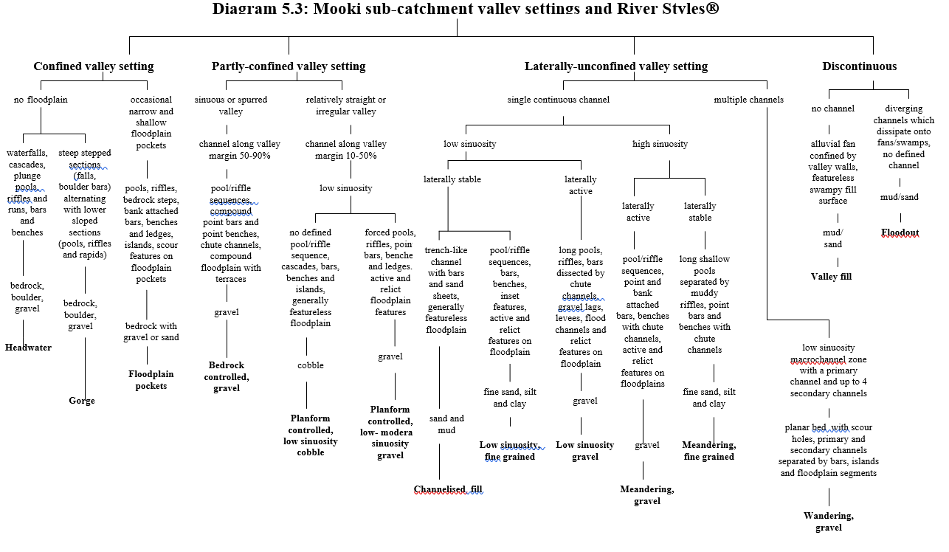



**Diagram 4** - River Styles extract

These maps show the extent and River Styles identified for the three major Wallabadah Creek Catchment drainages, as well as some of the smaller drainage units within the sub-catchment and provide an assessment of the conditions of the stream at the time, providing an independent benchmark for deterioration and rehabilitation.

The authors of River Styles describe both Wallabadah Creek and Jacob & Joseph Creek sub-catchments as an upper catchment “rugged volcanics” landscape unit, and Report:

The *Rugged Volcanics landscape unit occupies the ridges and hills of the Liverpool, Warrumbungle and Mt Kaputar Ranges. Although similar in morphological characteristics to the Rugged Meta-sediments landscape unit, it is dominated by volcanic geologies (sandstones can outcrop on the lower slopes, especially in the Mt. Kaputar area). These geologies tend to have* ***greater infiltration rates*** *resulting in reduced runoff rates and more attenuated flood discharges.*

*However, the steep slopes and confined valleys combine to generate relatively high peaked flows. Again, steep slopes result in the significant delivery of sediments to valley floors, which are often mantled by coarse cobble and boulder deposits. Sediment storage is usually limited to small pockets of floodplain that can be reworked over short to moderate timeframes (i.e.10 – 1000 years).*

Again, this supports the previous recommendations/conclusions. Land use planning and management activities consistent with the capability of the land class – see 6 - clearly can have a significant positive influence on infiltration rates within the catchment and broader catchment health.

Not only is this a management message for the high catchment but it should guide the management practices across the entire catchment if optimum water security outcomes are to be achieved.

|  |
| --- |
| **Diagram 5** - River Styles Extract |

Again, the message from this diagram is consistent with previous advice. The higher the elevation, the greater the bias for runoff.

The fundamental direction indicated by River Style is….keep it simple. Practically, from both a catchment and individual landholder level, start at the top of the catchment or your landholding high point, and catch/slow/spread the water from there.

* River Styles Stream Condition - Groundwater

|  |
| --- |
| upwall_geol.jpg |
|  |

Condition is as much a product of land usage as geology. Get the usage correct from the top of the catchment and everybody in the catchment wins!

* Groundwater Bore Locations – see attachments to Report

A copy of the DPI Water is attached.

|  |
| --- |
| aquifer types.jpg |
| **Diagram 6** - Rough aquifer types – based on Geology (Source: Banks 2019) |

This diagram again reinforces the management options previously highlighted. The capacity of the catchment to retain water from top to bottom in fractured or porous rock is highlighted. The issue for agricultural management is ensuring maximum infiltration at the highest points in the catchment.

|  |
| --- |
| * River Styles Stream Condition – see attachments to the Report   The condition of drainages is substantially a product of land usage. |

**Water Resources and Uses in The Wallabadah Creek Sub-Catchment**

It is generally accepted by the WCCC members that water security is essential to their personal sustainability and to a sustainable and economically viable agriculture based local community.

With this in mind, the fundamental objective is to secure and retain to as much good quality water as might be available within the system. Storage, access and optimising water efficiency are critical elements in achieving this objective.

The table below identifies water source/use parameters for the Wallabadah Creek Catchment Community and its members, based on general assumptions drawn from member consultations.

|  |  |  |  |  |  |  |  |
| --- | --- | --- | --- | --- | --- | --- | --- |
| **Table 3** | | | | | | | |
| **Water Use** | **Water Source** | **Access** | **Water Storage** | **Quantity Required** | **Quality of Source** | **Quality Required** | **Reliable** |
| Potable -homestead | Rainfall | House plumbing | House tanks | Low | High | As high as possible | Medium |
| Groundwater | House plumbing | House tanks | Low | Medium | As high as possible | Medium |
| Delivered | House plumbing | House tanks | Low | Medium | As high as possible | Medium |
| Stock watering | Local creeks and watercourses | Direct access to drainage lines | Nil | Medium | Medium | As high as possible. | Low |
| Alluvial/ shallow groundwater aquifers | Troughs | Pumps, tanks, pipe network and troughs. | Medium | Medium | As high as possible. | Medium |
| Dams | Runoff | Dam | Medium | Low-Medium | As high as possible. | Low to medium |
| Deep folded rock aquifers | Troughs | Pumps, tanks, pipe network and troughs. | Medium | Medium | As high as possible | High |
| Non-irrigated pastures - native or exotic | Rainfall | Natural processes | Biomass, soil profile, soil organic matter. | As much as the system can store. | High | As high as possible. | Mercy of the gods |
| Pasture -irrigated | Ground water/ alluvial | Irrigation infrastructure. | Nil | High | Medium | As high as possible. | Medium |
| Town water supply | Rainfall | House plumbing | Domestic tanks | High | High | As high as possible | Medium |
| Groundwater from both deep rock aquifers alluvial and | House plumbing | LPSC storage and pipe network | High | High | Medium | Medium/ High |
| Biodiverse conservation | Rainfall | Natural processes | Biomass, soil profile, soil organic matter | Minimum amount to provide ecosystem function and resilience | High | High | Natural water cycles |
| Generally groundwater dependent ecosystems | Rainfall/ alluvial aquifers | Within root zone of veg | Biomass, soil profile, soil organic matter | Minimum amount to provide ecosystem function and  resilience | High | High | Intact landscapes high  Degraded landscapes low |

* A review of topographic and historic parish maps. These maps offer information about former channel sizes, their planform position, a channel’s meandering pattern and the location of historical, floodplains and swamps and cetera. This allows comparison between the current and historic channels, and consideration to be given to any impacts of any changes
* A hydraulic analysis has been undertaken for various points in the drainage network, to ascertain the theoretical channel flows and the associated in channel energy levels which the channels are experiencing. This assists in considering management options as well as potential for instream works
* A preliminary review of the literature associated with channel evolution in similar landscape setting has been undertaken.
* An adaptiv representative travelled to the Wallabadah Creek Catchment for a week in March 2020 to gather information for this assessment, as well as assisting the implementation of Stage II/III works at the Jobys Hill Water Gully Creek Rehabilitation Project. Four days were allocated within the week to meet with landowners across the catchment to discuss matters relating to landscape rehabilitation/rehydration.
* The adaptiv representative also visited Wallabadah in late November for seven days to consolidate and confirm various aspects of the drainages (after some 800 mm of rain during the intervening period). In particular, adaptiv’s work plan was to assess the catchment watershed, the full extent of both Back Creek to its junction with the Wallabadah Creek and the full extent of Water Gully from its source through the Racecourse and Wallabadah village reaches to the Quirindi Creek. This has resulted in both conceptual and specific advices being provided to affected WCCC members on Back Creek, the Wallabadah Racecourse Trust and the Wallabadah Community Association.

# Further Background Material Sourced by adaptiv

An assessment of the drainage network across the sub-catchment has been undertaken for the purpose of establishing a current condition of the drainage channels and floodplains. Sources included:

* adaptiv site observations of the contemporary and historic geomorphic processes and the associated vegetation dynamics during the catchment and landholder visits.
* Local knowledge gained from on-site discussions with the landowners and property managers

**Wallabadah Creek Catchment Community Consultations**

As previously indicated, ten member property visits/consultations were undertaken by adaptiv, in early 2020. A form/visit Reports were completed for each of the properties to capture the information from these inspections and to provide any site-specific advice for management of any identified site issues discussed. Whilst these Reports are considered confidential, they can be viewed on WCCC’s google drive with the consent of the specific landholder.

In summary, the conversations with landholders sought to capture local knowledge to inform site specific issues, and to hear the history of the area and any changes observed by long standing community members. Some of the topics were farm specific – unique drainage issues, pest/weed control – whilst others were issues which were of a more universal and general concern. These broader issues came up in most of the landholders conversations, and present opportunities for – and in some cases require - local collaboration between landowners, and the strategic engagement of 3rd party stakeholders/in kind investors such DPI, NWLLS, regional Landcare, peak industry bodies and so on.

Below is short list of the issues raised:

* Site/landholding specific issues associated with drainage and instream rehabilitation options
* Catchment water cycle management generally
* The fundamental importance of ground cover, standing and dead timber and slowing water flows from the watershed of the catchment – and of individual landholdings - to the drainage lines for erosive and infiltration outcomes.
* Site/landholding specific strategies and works which could be implemented to improve groundwater conditions.
* The fundamental importance of groundwater for the sub-catchment enterprises across the board
* Experiences of or interest in strategic and/or time-controlled grazing.
* Weed dynamics associated with recent post drought pasture responses to rain in early 2020 and specific weeds like blue heliotrope
* Loss of topsoil
* The importance of slope in controlling runoff
* Feral animal control, in particular kangaroos and wild dogs, and particularly at the perimeter of the watershed, and the down catchment benefits
* The flow resisting membrane in the installed structures i.e. geofabric.
* Stock watering – discussion of pros and cons of various stock watering options and the limitations of storing water in dams.
* Riparian exclusion fencing pros and cons
* Conditions which influence runoff and drainage flows.
* Importance of shelter to help ewes to protect their lambs, and the need for it to be in close proximity to water. An increase in lamb survival rates in the order of 40% was observed when shelter was available for sheep.
* Water quality for stock and personal consumption
* A catchment based approach which considers groundcover across the catchment
* Vegetation dynamics, including the role of weeds – Pigweed and blue heliotrope were identified as examples
* Soil health generally, and soil carbon levels specifically
* Roles of subtropicals and/or deep-rooted natives

**adaptiv Observations and Recommendations**

**The key issue for catchment water security, or the deterioration thereof, is the gradual increase in velocity and volume of surface flows as the result of traditional grazing practices/lack of pasture cover and clearing.**

As a consequence of this increasing velocity across the catchment, there has been **significant deterioration in the condition of all drainages**, and many of the features listed in Table 4/5.3 above have been lost. There has been wholesale erosion which has migrated upstream from Wallabadah Creek up into the lower order creek and gullies within the catchment, extending to the watershed. There is widespread evidence of channel lowering, straightening and subsequent channel expansion.

The regeneration of pasture and tree cover is the fundamental management tool for landholders to start slowing and catching these surface flows and creating conditions for optimising infiltration and groundwater recharge.

Changes in grazing and water management, as well as tools like the crocodile seeder and Aerovator/air seeder are relevant to this objective. However, such issues are beyond the ambit of this Report.

However, these management changes will be benefited by drainage and other methodology to slow and spread water.

The conclusions of a Study in 2019 by Banks of conceptual catchment groundwater levels and behaviour in the alluvial aquifers in the Wallabadah are shown below. The following diagram illustrates the potential impact on groundwater levels where in drainage works are initiated.

|  |
| --- |
|  |
| **Diagram ??** - Conceptual drawing of the nature and behaviour of the groundwater in the alluvial aquifers of the Wallabadah Catchment (Source: Bank (2019)) |
| **Conceptual aquifer level after works** |
| **Diagram ??** - Potential impact of instream works on the level of groundwater in an alluvial aquifer. |

**Water Gully Jobys Hill Demonstration Site**

There is currently a creek rehabilitation rehydration demonstration site in the Water Gully sub-catchment on the Jobys Hill property in the lower Wallabadah Creek Catchment.

Water Gully is a heavily eroded drainage on the SW side of the main Wallabadah Creek Catchment which rises about 4 km to the SE of Wallabadah, runs W and then around the western edge of Wallabadah village, and then N to join the Wallabadah/Quirindi Creek.

The works have been done in collaboration with NWLLS and were commenced in October 2019.

The reach in which the works have been constructed stretches approximately 700 m including works in a side gully. Plans are in progress to extend the works on a further 700 m downstream in the Wallabadah Racecourse reach of Water Gully during current year.

At the time of preparation of this Report, 6+ structures have been installed through the reach.

All are constructed with material sourced in the landscape or otherwise sourced locally. Some materials used might appear, to some, as rubbish or waste. However, each structure is designed and constructed to:

* meet clear rehabilitation/rehydration objectives, based on sound engineering and hydrological principles, similar to other proven rehabilitation/remediation structures.
* be easily replicable by landholders elsewhere in the catchment with readily available materials, their own equipment and where their own drainage circumstances determine

A key design feature of the 3 major structures is the installation of a geofabric membrane from the top of the structure to +/- 4m below existing bed-level.

|  |
| --- |
| **Diagram ??** - The Water Gully catchment is 4 km2 to the NE Highway  Bed log sill 0.8m high – S1  Leaky bed log sill 0.5mm high – S3  Bed log sill (Vehicle crossing) 0.6m high – S2  Raised sill 0.6m high – S1(a)  Tyre flume (Type I)–S4  Tyre flume (Type II)–S5  Timber log bank revetment–S6  Timber log bank revetment–S7 |
| The locations of the works as executed structures at the completion of Stage II in the development of the Water Gully Demonstration Site. The creek flows from the bottom to top of the photo. |

**Water Gully Demonstration Site – Lessons Learned**

Stage 1, completed in late 2019 before the early rains in January 2020, and Stage 2 , which was completed in late March 2020, feature several different types of instream erosion control and structures designed to restore the stability and ecological function of this section of the drainage.

|  |
| --- |
|  |
|  |

To ensure the works were appropriate, adaptiv undertook a detailed site assessment recommending the positioning, number and type of natural structures to be installed. This assessment considered the rehabilitation reach itself, as well as the overall catchment and the reaches of the creek immediately upstream and downstream of the rehabilitation site.

It was identified that the extensive bed erosion and cutting down of the bed of Water Gully has been as a result of a combination of factors including the change in land use following settlement of the area, land clearing and channelisation of the creek. The cutting down of the creek has resulted in the creek banks being much higher than they would have formally been making them far more unstable and prone to erosion. Another consequence of the bed lowering has been a corresponding drop in the level and capacity of the shallow alluvial aquifer. The lowering of the water table can also result in a reduction in the quality of this water.

Much of the main features of the instream works are built from a combination of local natural materials and/or redundant farm resources including fallen timber, rock, old fence posts and gates as well as repurposed steel bore casing. These works are designed to arrest the bed and bank erosion and to progressively raise the bed of the creek. As well as physically raising the bed of the creek the series of structures roughness the creek channel which has the effect of slowing the creek flows and encourage sediment to be trapped between the structures. This further raises the creek bed and improves the conditions for native plantings and natural regeneration.

The works are low tech and low cost by design demonstrating works that local landowners can build them with their own resources. Local earthmoving contractors were used to build the works thus increasing the community’s capacity in the construction of this type of works. If a landowner is considering undertaking these works, it is important that they obtain any necessary approvals or permits before commencing any works within a riparian channel. Talk with local NWLLS contact to see what approvals are required.

|  |
| --- |
|  |
| Figure: |

*Installation of a log sill across the channel. The sill will assist in slowing the water thus reducing its erosive power and to create conditions for sediment to deposit and raise the channel bed. Raising the bed of the channel will reconnect the creek with its floodplain. Once the floodplain is reconnected more of the water will be spread out over the floodplain reducing the destructive impact of larger floods, further improving the stability of the creek.*

|  |
| --- |
|  |
| Figure: |

Since the works have been installed there has been significant sediment deposition and extra moisture levels are evident. These conditions have allowed the successful reintroduction and regeneration of native vegetation. There is also evidence that the works focused on intercepting and slowing the movement of the shallow groundwater are working.

|  |
| --- |
|  |
| Figure: |

*Recent deposition in the creek bed is evident from rainfall events in early 2020 and in some places, this deposition is up to a metre in depth. It can be seen from the photo that tree planting has been undertaken to further stabilise the creek bed and banks and that groundcover is rising.*

When the skies opened in January 2020 it generated several large flow events on relatively insignificant falls of 15 to 20 mm. This resulted in the areas between the structures pooling water and catching enough sediment to raise the bed, over about 500 metres, up to 1.5 metre in places. Estimates of sediment caught in the works are conservatively estimated at between 3000 and 5000m3 of topsoil.

Subsequent major flows, including one which flooded the village, saw additional sediment deposited in the rehabilitated section of the creek, while unrehabilitated sections of the creek experienced significant bed lowering and associated bank erosion.

**Initial Lessons**

1. Slowing of water in typical sub-catchment drainages, using well designed, appropriately positioned natural bed controls can be achieved efficiently and cost effectively.
2. Works should generally be built in series.
3. If vegetation is planted in-channel planting of endemic riparian pioneering species is recommended. Positioning these plants strategically within the channel where they would naturally establish, rather than general wholesale planting of the channel. It also appears to be benefited to achieve the best percentage of plant survival, optimise plant growth rate, reduce channel velocities and encourage in-channel sediment accretion.
4. Planting of the floodplain or top of bank is not recommended as it has little impact on channel recovery and these plantings usually experience an extremely high mortality rate. There are a number of large trees which are providing the top canopy at a cover and density similar to the surrounding woodland environment. Again, once the stock is removed or appropriate time controlled practices, the natural regeneration processes, specific to these species will be triggered. When this occurs an assisted regeneration approach can be taken to support these plants in their initial stages of establishment.

The evidence from Water Gully is that where stock are absent native grasses and shrubs quickly regenerate naturally removing the need for their reintroduction by planting. If after some monitoring it becomes clear that critical individual species have not regenerated then strategic planting of this species, using plant local provenance plant material, in localised sites consistent with their natural niche, would be advantageous.

1. Allowing natural regeneration of the locally represented plant species, as opposed to planting of trees and shrubs, will improve the overall success of the revegetation program and remove any risk of plants without of area provenance being planted.

Research has established that ungrazed vegetation, in particular native grasses, have been successful in stabilising eroding channels and trapping mobile sediment. Once this vegetation is established there is a good chance that a modified in-channel swampy meadow will form.

As well as stabilising the base of the channel, this vegetation increases the channel roughness further slowing channel velocities and encouraging sediment deposition.

Evidence of all these factors is found in Water Gully.

1. The rewetting of the drainage within the reach, using surplus bore water, could be trialled. This may promote and/or accelerate the macrophyte/swampy meadow growth in the base of the channel. Large macrophytes including Phragmites and Cumbungi need access to permanent moisture to establish.
2. Banks (2019) identified that the majority of catchment bores are in landscape settings where the water sources are alluvial, like Water Gully. These alluvials are porous and have a strong hydrological relationship with the adjacent creek lines.

All the creek lines inspected in the sub-catchment showed evidence of bed lowering. As a result, not only is the creek channel deeper and more prone to erosion but there will also an associated reduction in the storage capacity of the shallow alluvial aquifers in the system.

1. In addition, many of the elements which slowed the movement of ground water through the system - fallen logs, high organic matter soils, swampy meadows and larger volumes of water – have been removed or have disappeared. Again, this is the case with Water Gully. The ground water is also well below the root zones of plants which removes the possibility for plant growth in these large alluvial areas. Removal of these elements increases the efficiency of the rate of lateral movement of water accelerating the depletion of the alluvial aquifers.
2. Where there are lower volumes of groundwater in the system there is limited dilution effect and any salts or contaminants are concentrated in the existing flows, reducing the water quality.

All of these landscape elements are present within the sub-catchment. The rainwater intercepted by these landforms are effectively the water source for the shallow alluvial aquifers within the catchment.

The nature of the Wallabadah Creek sub-catchment means it is a closed system where the rain which falls and infiltrates into the landscape higher in the catchment is the primary (likely only) water source for alluvial aquifers throughout the sub-catchment, and by extension the lower reaches including the village of Wallabadah.

***By taking a whole of catchment appropriate the WCCC has the individual and collective ability to implement land management practices and landscape restoration works similar to those installed at Water Gully which have a positive effect on long term water availability, security and quality which the subcatchment.***

**Optimising Infiltration/Reducing Runoff**

From our on ground and research preparation for this Report, ***adaptiv’s conclusion and our key recommendation is optimising infiltration or reducing runoff from the highest points in the catchment is the highest order objective for the sub-catchment members individually and collectively if they wish to influence water security at surface and subsurface.*** This is the principle which needs to guide **all** management actions and projects into the future.

Whilst the principle is not novel at an academic level, the following diagram illustrates its relevance for day by day basis by the member land managers endeavouring to run productive and profitable farming business with a productive valley community. Below is a graphic representation of this idea.

|  |
| --- |
|  |
|  |

Reduction of run off/minimisation of water loss has a direct correlation with improved productivity. The alternative means a long-term deterioration of productivity, related profitability and, ultimately, the ability to operate when water security disappears.

**Wallabadah Catchment - Drainage Recommendations**

The outcome of the above principle is that management and practices which promote 100% pasture/vegetation cover 100% of the time are the highest priority. As stated before, these are beyond the ambit of this Report. These recommendations deal with the existential issue once water begins to flow in the sub-catchment landscape and existing degraded drainages.

Rehabilitation approaches which exploit the natural recovery processes operating in a drainage and biases the drainage into a trajectory of recovery will require the least intervention, offers the most cost-effective solution with the lowest inherent risk.

The following principles should be considered:

1. Use on site materials – fallen timber, old wire, mesh, panels, gates or machinery capable of providing a barrier, even tyres on low velocity drainages where they can be secured – to minimise cost.
2. In high velocity drainages, the use of geotechnical mat should be considered.
3. Remember that re-establishing the stability of the bed is critical to achieve a successful rehabilitation outcome.
4. Remember further that the whole exercise is aimed toward plant regeneration in stream and banks.
5. Any material – rocks, logs – which roughen the creek bed and take energy out of flow are useful.
6. Physical bed raising works are recommended to reduce the overall channel capacity, reduce the height of the banks and to reduce the gradient between the bed controls.
7. Don’t be too aggressive with structure size, as you can always come back and repeat the exercise when the first has been successful.
8. Look for opportunities to reengage the old floodplains – billabongs, old streams.
9. If an alluvial aquifer is present below the bed of the stream, strategies to restrict the movement of this water through the porous alluvial gravels would be beneficial. Any additional water in the base of the creek will encourage and support the growth of in-channel vegetation.
10. Start as high in the country as you can remembering that no stream is too small.
11. Whatever anyone else tells you, casuarinas are good. Phragmites, cambungi, pin rush and native vetiver are good in stream revegetation alternatives. In the initial phases, even weeds are good,
12. Build works in sequence – 3 or 4 at a time – and remember that that the downstream structure needs to be the strongest.
13. Remember that works will concentrate stream flow energy is concentrated as the water falls over the structure, reducing the available energy in the remaining sections of the channel. This improves conditions for vegetation establishment and for other softer engineered structures to be successful. Plant every time you have moisture up stream of structures.
14. Installation of the flow retard sills/girdles provides immediate roughness to the channel in advance of the reestablishment of vegetation. The cross-section of each structure restricts flows reducing flow velocities upstream which in turn encouraging sediment and seed deposition. Low tech rural fencing techniques and old star steel posts pin weirs are good alternatives in all but high velocity, high volume streams. Again, remember that failure can always be replaced without costing the earth.
15. As illustrated by the structures at Water Gully, the majority of structures can be constructed with existing farm equipment and resources. If you need to go beyond your own resources, remember local capacity and knowledge already exists.
16. The ability to exclude stock from the riparian zone is highly desirable. This does not need to be a life sentence but is essential in the initial 6 – 12 months to optimise revegetation and bed/bank stability stock excursion or limited time-controlled grazing is recommended in the riparian zone. If exclusion fencing is used, the widest buffer from the top of the creek bank – 20 to 50 m - will be most beneficial.
17. Dams are not a cost effective or functional way of managing water flows in drainages, nor a valuable addition to subcatchment water security, given the porous nature of soils and long term weather trends. Money is better spent on rehydration and promoting infiltration.

**ATTACHMENTS**

1. **Map Layers produced by NWLLS**
2. **Extracts from the Namoi Sub-Catchment River Styles.**
3. **Site specific property Reports**