Wallabadah Sub-catchment site data collection sheet
Contact: Brad Davies - adaptiv |  | t: 0418 148 885 | Email: adaptivbynature@gmail.com
Landholder: Crown Land managed by NPWS/Forestry |  |  | Date: 28 March ‘20 | Time: 1330 -1345 | Site Ref: Nature Reserve 1
Landholding: Wallabadah Nature Reserve
Address: Wallabadah Creek Road, Wallabadah via Creek Heights |  |  | Email:
Lot: | DP: |  | Mobile: 0428658149
GPS Coordinates: Refer to photo |  |  | Observer/s: : B. Davies/G. Macdonald
Waterway Name: Quirindi/Cutters Creek
Project Reference:  Inspected as part of WC tour. Recently burned in 2019/2020 bushfire season. Not extensively logged for over 30 years. Access work weed infestations apparent. |  |  | Land use:  □ Grazing (specify):_____________  □ Cropping  □ Irrigation  □ Urban  Native vegetation(specify): NA  □ Private conservation  Other: Public Reserve
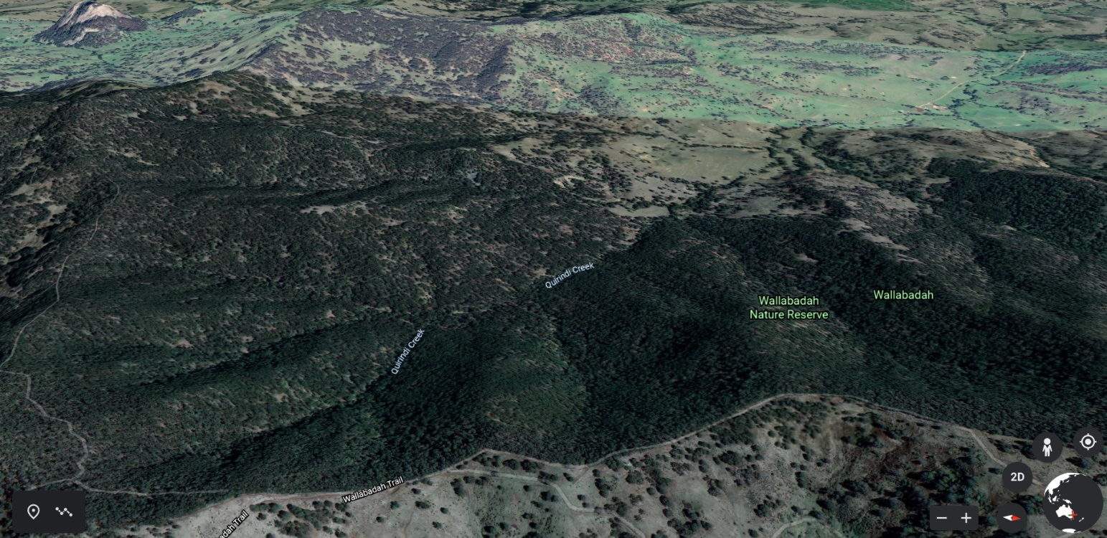
Figure 1: Is a view of Wallabadah Nature Reserve looking downstream Wallabadah catchment

Soil type/landscape  Soil landscape:  Geology:  Soil texture:  Notes: |  | Vegetation/Ground Cover  Type:  Notes:
Stream Style:  □Gully  Headwater  □Waterfall  □Gorge  Laterally Confined  □Non-laterally Confined  □Valley Fill  Channelised Fill  □Planform Controlled  Bedrock Controlled  □Artificial  □Other:  Notes: High sinuosity laterally confirm fine grained headwater stream. |  | Channel features:  Pool  Riffles  □Bar/s  □Benches  □Notches  □Scarps  LWD  Bedrock  □Grass swale  □Artificial  □Other:  Notes: Contour bank
Floodplain features:  Paleochannels  □Ponds  □Bar/s  □Benches  □Terraces  □LWD  □Porous  □Other: contour bank  Notes: |  | Sinuosity (1.0-1.05(Straight), 1.06-1.30(low sinuosity), 1.31-3.0(Sinuous, Meandering):  □ Straight  Low Sinuosity  □ Sinuous/Meandering  Notes:  Stream order No. 2nd
Channel geometry  Channel slope/gradient: Approx. 10%  Channel depth(m):  Channel width(m):  Floodplain width (m):  Bank profiles: (observations taken looking downstream)  □LB □RB □LB □RB □LB □RB □LB □RB □LB □RB  Concave Convex Vertical Planar Stepped |  | Catchment hydrology/hydraulics  Elevation(m):m  Base of catchment: m Top of catchment: m  Theoretical ARI Qm/s³:(2yr)_____(10yr)______(50yr)________  Notes:__________________________________________________  Observed flow:  No flow □Low □Moderate □High □Flooding  Notes:  Groundwater: Yes  Bore: NA
Bed material:  Bedrock  □Boulder  □Cobble  Gravel  □Sand  □Fine grained  □Organic  □Artificial  □Other  Notes:  Average Particle Size (B axis) (mm):  Sediment: Heavy clay |  | Bank material:  Bedrock  □Boulders  □Cobble  Gravel  Sand  Fine grained  □Organic  □Artificial  □PESA  □Other  Cohesive or incohesive: Cohesive  Notes:
Bed instability present? (U/S, D/S and/or at the site)  □None  Bed incision  Headcut  □Tunnelling  □Gully Head  □Other  Notes: Localised | Bank erosion present? (U/S, D/S and/or at the site)  □None  Slumping  Undercutting  □Notch/scarp  □Rilling  □Surface stripping □Other:_________________  Notes: Localised | Tree fall/Woody Debris  In channel: Yes / No □  Notes:
Tree fall/Woody Debris
Floodplain: Yes / No □ / NA □
Notes:

Riparian Vegetation  Riparian vegetation present? Yes / No □  Notes:  Species:  Too many to list |  | Floodplain vegetation present  Floodplain vegetation present? Yes / No □  Notes:  Species:  Too many to list
Site observations/discussions.
The Reserve is generally in very good conditions. Recovery following the Dec 2019 fire has been outstanding, and the burn is possibly for many of the observations below. The channel network that was observed were in responsibly good condition.
Some key observations were:
Native vegetation was re-establishing well following the fires with no emergent weed issues. There is a large diversity of native vegetation which is regenerating. The only issue was weed prevalence on the disturbed country which has been exacerbated by fire trails during the fire. This may have a significant effect down catchment with travelling seeds, and NPWS may consider addressing this if asked.
Tree violet is common along the creek lines and is provided important habitat for small birds.
Fallen timber is naturally providing bed and bank protection. A number of examples were seen, which were trapping gravel and raising the creek bed. These trees fell into the creek from the floodplain.
Potential Remediation Actions/ Priorities/ Works
No obvious issues identified except weeds in newly disturbed country. Suggest WCCC ask NPWS to consider managing this and revegetating bare or weed covered areas to remove down catchment impact. It would not be a large job.
Inputs Required
NA

